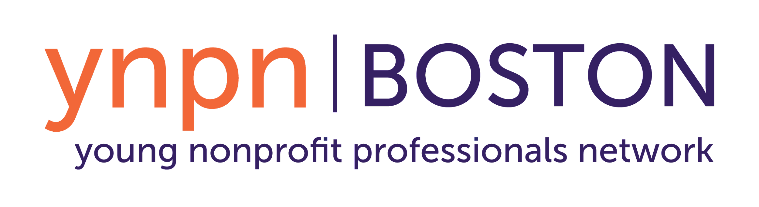

Overview: Recruiting for Ambassador Roles for YNPN Boston

About YNPN Boston
The Young Nonprofit Professionals Network (YNPN) Boston, was founded in 2007 to provide support and resources for young professionals working in the Greater Boston nonprofit community. Our mission is to develop a stronger, higher impact nonprofit community in Boston by engaging young talent and their organizations in professional development and human capital management practices. We host networking and professional development events to bring nonprofit professionals together and introduce them to Boston-area opportunities. Today, we’re connected with over 9,000 users through our listserv, social media, and events.

YNPN Boston is run by the all-volunteer YNPN Boston Leadership Team of motivated and talented young professionals like you! As a result of our current strategic planning process, some of these positions’ descriptions will evolve over the next year or two as our Leadership Team structure is aligned to better meet our operational needs. A current description of each open position can be found below.

Application Link: https://forms.gle/o3Syg4GUUEWHqucQ8

About the Ambassador Program
YNPN Boston is seeking passionate, driven, and organized individuals to serve as Ambassadors on our Leadership Team. Ambassadors are key to YNPN Boston and our ability to achieve our goals. While our Board oversees the strategic direction and management of the organization, Ambassadors carry out strategic actions in specific functional areas. Together, Board Members and Ambassadors make it all happen! This is a great opportunity to develop skills in an area that you haven’t fully explored or to contribute your expertise to one of Greater Boston’s nonprofits.

In addition to developing skills in specific functional areas, Ambassadors participate in networking and professional development meetings and receive free admission to all YNPN Boston events! Beyond skill-building, our Leadership Team is a network of over 30 like-minded, driven emerging leaders in Greater Boston’s nonprofit community! We are all extremely committed to YNPN Boston’s mission. In fact, many current Board Members first got involved with YNPN Boston as Ambassadors.

Qualifications for Ambassador Positions:
- Passion for nonprofit organizations and employees along with a desire to improve the nonprofit sector and to enhance the lives and careers of young nonprofit professionals in Greater Boston
- Professional, proactive communication skills
- Ability to translate ideas into action
- Project management skills, with flexibility to manage projects both independently and collaboratively, and a professional approach in the presence of ambiguity
- Ability to dedicate approximately 12-15 hours of volunteer service each month to YNPN Boston and to attend 75% of YNPN Boston meetings and events
- Interest in and comfort working and collaborating both in-person and virtually (as an all-volunteer organization, we use Google Suite and Slack to drive our work between meetings)
- Willingness to make a financial contribution within your means

YNPN Boston values diverse professional and personal experiences and perspectives. As an organization, we strive to be intentionally inclusive and to reflect the community that we serve, and we encourage individuals from all backgrounds to apply for the Leadership Team.

Ambassador Expectations

As a YNPN Boston Ambassador, I will:
- Commit to serving a one-year term, renewable
- Dedicate an average of 3 hours per week to YNPN Boston-related work and activities Note: Depending on your team, some times may be more or less busy than others, and you remain responsible for proactively collaborating with other teams during their busy periods as well.
- Attend the following, which take place in the evenings:
  - Monthly team meetings (1-2 hours)
  - Quarterly Leadership Team meetings and socials (2 hours)
  - Monthly YNPN Boston events (1-2 hours)
    - Attend at least 75% of events each year and volunteer at 2-3+ events annually
- Communicate in a timely manner if I cannot complete a task or attend a meeting or event
- Respond to all YNPN Boston-related emails within 48 hours
- Make an annual gift at a level that is meaningful to me (suggested range $30-$75)
- Represent YNPN Boston to the Greater Boston community (and beyond!)
- Be a team player in supporting the mission of YNPN Boston
- Help the Leadership Team meet our organizational goals for the year
- Be bold and take new steps in my professional development journey

My 3 hours per week dedicated to YNPN Boston could include but may not be limited to:
- Participating in a Leadership Team meeting organized by the Board
- Participating in a team meeting organized by the Director(s) leading my team
- Attending a YNPN Boston networking or professional development event
- Independently completing work to support team projects
Note: This could include additional meetings, phone calls, etc.
- Initiating and responding to communications from other Leadership Team members

As an organization, YNPN Boston will:
- Be understanding that people have busy lives
- Give timely notice for important dates
- Support you in your professional and personal growth
- Connect you to professional development opportunities and a network of peers
- Provide you with free admission to all YNPN Boston professional development events
- Provide you with opportunities to practice new skill sets

Spring 2026 Open Positions

Ambassadors commit to serving a one-year volunteer term on one of the following YNPN Boston teams.

Programming & Events
Ambassadors on this team will work closely with the Co-Directors to plan, organize, and execute monthly networking and professional development events. We are focused on offering a range of engaging events to move the nonprofit sector forward by building capacity, relationships, and transferable skills. Ambassadors typically assist event planning and execution by having delegated responsibilities such as sending event emails to our Network, gathering supplies such as refreshments, and "working" events by attending, setting up and representing P&E and YNPN Boston. They will also have the opportunity to have ownership over a few events per year, taking point from the concept stage to execution. This is a great opportunity to gain experience in nonprofit event management with a fun, committed group of young nonprofit professionals.

Communications & Marketing
This team oversees external communications for YNPN Boston with a focus on enriching and growing the organization’s online presence and brand awareness. C&M manages the YNPN Boston website, blog, listserv, and social media channels—developing and curating content, creating graphics, monitoring and responding to interactions from members, maintaining the technical side of these communications channels, and evaluating their reach and effectiveness. They also oversee organizational messaging and branding, create tools and templates to maintain consistent organizational look and voice, and help implement initiatives. With increased capacity, the team hopes to explore more avenues for digital communication such as email marketing.

Fundraising
In the upcoming year, the Fundraising Team will continue to enhance and deepen its fundraising efforts through a variety of funding streams such as: individual giving, event and/or corporate sponsorships, and in-kind donations. We encourage creativity and the exploration of new opportunities. Ambassadors will gain hands-on development experience from the ground up and have the opportunity to closely collaborate with other YNPN teams such as Communications & Marketing and Programming & Events. No previous fundraising experience is required as we welcome skilled and motivated individuals from all disciplines and diverse backgrounds. Got an out of the box idea? Explore it here!

Recruitment & Engagement
Talent & Recruitment Team Ambassadors will be involved in a number of projects focused on talent acquisition and management for the YNPN Boston Leadership Team. The Talent & Recruitment Team oversees the Board and Ambassador recruitment process each year, plans and facilitates Leadership Team onboarding sessions and meetings throughout the year, and provides the Leadership Team with regular professional development opportunities. The Talent & Recruitment team also develops strategies and tools to measure the experience and success of the Leadership Team

